(1)

> **12+4-5;**



> **2^10;**



> **sin(0.1);**



> **(a+b)(a-b);**



(2)

> **diff(3*x^3+2*x^2-5,x);**



> **diff(sqrt(1+x^4),x);**



> **diff(exp(x)*sin(x)*cos(x),x);**



(3)

> **int(3*x^3+2*x^2-5,x=0..1);**



> **int(1/x^2,x=0..infinity);**



> **int(exp(-x^2),x=-infinity..infinity);**



(4)

> **limit(sin(x)/x,x=0);**



> **limit((x^3+3*x^2-5)/(2*x^3-7*x),x=infinity);**



> **limit((cos(x)+1)/(x-Pi),x=Pi);**



(5)

> **plot(exp(-x)-1,x=-2..2);**

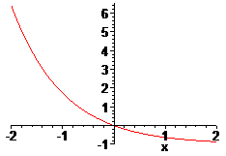

> **f:=(x,r)->(200*exp(r*x))/(2*(exp(r*x)-1)+100);**



> **plot([f(x,0.5),f(x,-0.5)],x=0..50);**

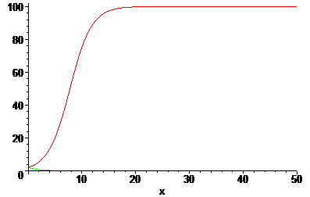

> **plot(x*sin(1/x),x=-3..3);**

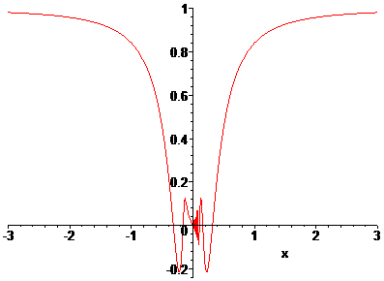

(6)

> **plot([(1-cos(t))*cos(t),(1-cos(t))*sin(t),t=0..2*Pi]);**

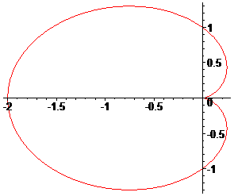

> **plot([sin(3*t)*cos(t),sin(3*t)*sin(t),t=0..2*Pi]);**

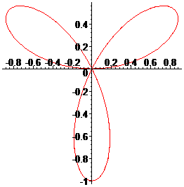

> **plot([t-sin(t),1-cos(t),t=0..6*Pi]);**

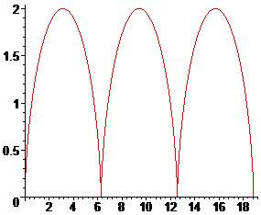

(7)

> **f:=(t,s)->1-((s*cos(4*t)*cos(t))/sqrt(1-s^2*cos(4*t)^2*sin(t)^2));**



> **plot([f(t-Pi/2,0.5),f(t,0.5),t=0..2*Pi]);**

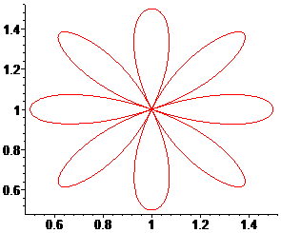

> **list_f:=f(x,i/10)$i=1..10;**



> **plot([list_f],x=0..2*Pi);**

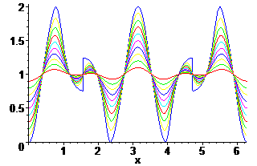

(8)

> **implicitplot(x^2+y^2-2*x-4*y+4=0,x=-10..10,y=-10..10);**

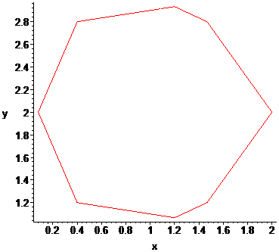

> **implicitplot(x^2-2*x*y-y^2=1,x=-10..10,y=-10..10);**

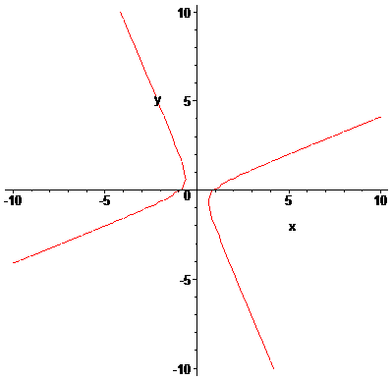

(9)

> **z:=(x,y)->4*x^2*exp(y)-2*x^4-exp(4*y);**



> **plot3d(z(x,y),x=-3..3,y=-1..1);**

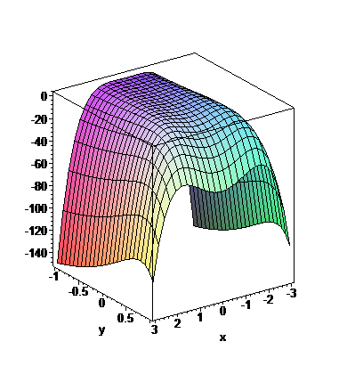

> **z:=(x,y)->4*x^2-y^2;**



> **plot3d(z(x,y),x=-100..100,y=-100..100);**

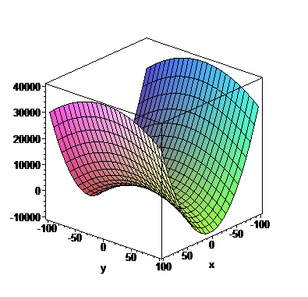

(10)

> **A:=matrix([[1,2,-1],[0,1,0],[3,-1,2]]);**



> **B:=matrix([[1,2,3],[0,1,-1],[4,2,2]]);**



> **C:=matrix([[2,1,1],[0,1,-1],[4,2,2]]);**



> **evalm(2*A-B&*C);**



> **evalm(B^(-1));**



> **eigenvals(C);**



> **eigenvects(C);**

